Technical Architecture & Product Blueprint: Proprietary Cash-Flow Lending Platform for Indian MSMEs
Building a fintech platform tailored for Indian MSMEs involves handling sensitive financial documents, integrating with localized Indian banking APIs, running a data-processing pipeline for credit scoring, and ensuring strict compliance with Reserve Bank of India (RBI) guidelines.
Here is a comprehensive production-grade tech stack categorized by layer to build this platform.
1. Mobile Front-End (Client Layer)
Since MSMEs use a wide variety of devices (including budget smartphones), the client application must remain lightweight and fast.
- Framework: React Native or Flutter. Both provide an optimized cross-platform native experience for Android and iOS.
- State Management: Redux Toolkit or Zustand (for React Native) to manage multi-step application forms and complex financial document upload states smoothly.
- Consent & Aggregator SDK Integration: Inclusion of native WebView or deep-linking components required to integrate with Sahamati Account Aggregator (AA) handles (e.g., Anumati, OneMoney, CAMS Finserv) for direct consent architecture.
- Document Handling: react-native-document-picker for clean manual uploads of legacy tax or invoice sheets.
2. Back-End Architecture & Scoring Logic (App Layer)
Building the predictive credit system, backend requires robust data-science Capabilities.
- Primary Framework: Python (FastAPI).
  - Why? Python is mandatory here. It allows the backend to double as your machine learning/statistical evaluation environment, using libraries like Pandas, NumPy, and Scikit-learn to process real-time scoring data without lag.
- Workflow Orchestration: LangGraph or Temporal.io. Credit assessment often requires complex, multi-step asynchronous logic (e.g., Upload Financials -> Run OCR -> Call Bureau API -> Calculate Score -> Risk Evaluation -> Disbursal Approval). A stateful graph or workflow engine prevents data loss if a third-party API times out mid-transaction.
3. Data Extraction & Native India Fintech Integrations
Instead of third-party bureau connections, capture primary financial footprints directly from official government and banking rails and official registries via REST APIs.
A. Real-Time Cashflow & Banking (Account Aggregator Network)
- Consent-Based Fetching: Integrate with licensed Account Aggregator Technical Service Providers (TSPs) like Setu (Pine Labs), FinBox, or Perfios. These APIs fetch clean, structured bank account transactions instantly across months without requiring physical PDFs.
B. Tax & Operational Footprint (GST & Corporate Registries)
- GST Returns API (GSTR-1 & GSTR-3B): Connected via infrastructure tools like SignalX, Decentro, or Attestr to query top-line sales, purchase frequency, and tax consistency.
- Udyam Verification API: Validates the validity of the MSME entity directly against the Ministry of MSME database.
4. Proprietary Analytics & Credit Intelligence Layer
This is the completely new engine section that replaces the traditional CIBIL bureau calls.
- Feature Engineering Pipeline: Pandas / NumPy routines built into your app to parse raw banking logs into distinct credit indicators (e.g., balance volatility, cash-inflow velocity, ledger health).
- Rules & Decision Engine: Drools or an inline Python engine like Business-Rules. This allows risk teams to alter internal score thresholds and loan allocation calculations without rewriting backend code.
- Audit & Explainability Log: JSONB storage tracking. RBI guidelines require alternative models to explain why an algorithm approved or denied a loan. Your backend must store the exact scoring weights snapshot alongside the decision.
5. Data & Storage Layer
- Primary Database: PostgreSQL. Crucial for maintaining transactional integrity, historical ledger entries, and accounting data with strict ACID compliance.
- Caching & Real-Time Metrics: Redis. Handles active session tracking, multi-factor authentication (MFA) tokens, and holds transient calculation states as your engine computes scores.
- Data Lakehouse / Cold Storage: Amazon S3 or Google Cloud Storage to save raw financial telemetry and historical tax records for future model retraining.
6. Security & Infrastructure (DevOps Layer)
Strictly governed by RBI’s Digital Lending Guidelines and Indian data sovereignty.
- Cloud Hosting: AWS (Mumbai Region - ap-south-1) or Google Cloud (India Regions) to fulfill mandatory data localization laws.
- Encryption Standards: Full envelope encryption with AES-256 for database files at rest, and TLS 1.3 for all APIs in transit.
- PII Protection: Strict masking protocols for sensitive founder data (like Aadhaar card details or PANs) before any logging occurs.
Modified Summary Stack for Quick Reference
Layer | Recommended Technology
Mobile App | React Native / Flutter
Backend Core | Python (FastAPI)
Data Fetching | Account Aggregator TSPs (Setu / FinBox)
Scoring Module | Pandas, Scikit-learn, Rules Engine
Tax/ID Verification | Decentro / SignalX (GST & Udyam APIs)
Database | PostgreSQL + Redis
Hosting Region | AWS / GCP (India Regions)
App Workflow:
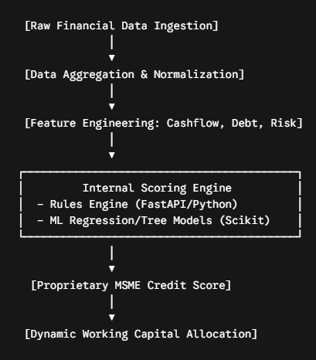
Data Processing Pipeline: Pandas / NumPy (embedded inside Python/FastAPI) to handle feature engineering. You will convert raw data points into distinct sub-scores (e.g., Banking Score, Tax Score, Stability Score).
Statistical Modeling & Weights: Scikit-learn or XGBoost. You can begin with a weighted rule-based matrix and gradually evolve it into a linear regression or gradient-boosting model that predicts default probability based on your historical cash-flow data.
Rules Engine Execution: Drools or an inline Python rules compiler (like Business-Rules or custom configuration dictionaries stored in PostgreSQL) to allow credit risk managers to tweak score thresholds without modifying the core backend deployment code.
Frontend model view:
When adapting this layout style for your MSME platform, we can consider specific design cues in mind:
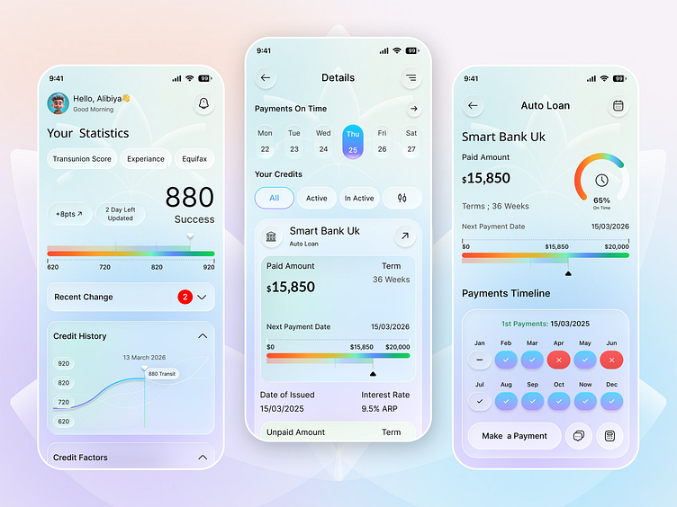

Prominent Scoring Meter: The first screen cleanly spotlights the overall numeric standing (like your custom 300–900 scale) directly beneath the user's operational statistics. A multi-color progression bar clearly signals to the business owner where they stand before applying for more capital.
Cash Flow Factors: The middle screen breaks down active lines of credit, upcoming dates, and repayment structures. In our app, this is where we can display components demonstrating why they received, their current tier—such as active indicators for GST regularity or Average Monthly Balance maintenance.
Immediate Allocation Breakdown: The final screen visualizes dynamic loan terms, remaining limits, and active drawdown options so the merchant can pull cash seamlessly into their corporate bank account with one tap.

